Project-CHSI

# Introduction

CDC(Centers for Disease control and prevention) helps protect America from health, safety and security threats, both foreign and in the U.S. whether diseases start at home or abroad, are chronic or acute, curable or preventable, human error or deliberate attack, CDC fights disease and supports communities and citizens to do the same.

CDC increases the health security of our nation. As the nation’s health protection agency, CDC saves lives and protects people from health threats. To accomplish our mission, CDC conducts critical science and provides health information that protects our nation against expensive and dangerous health threats and responds when these arise. Centers for Disease Control and Prevention (CDC) Community Health Status Indicators is a website that provides health profiles for all U.S. counties, including health outcomes, population health status, healthcare access and quality, health behaviors, social factors and the physical environment

**CDC’s Role:** * Detecting and responding to new and emerging health threats * Tackling the biggest health problems causing death and disability for Americans * Putting science and advanced technology into action to prevent disease * Promoting healthy and safe behaviors, communities and environment * Developing leaders and training the public health workforce, including disease detectives * Taking the health pulse of our nation

CDC produces Community Health Status Indicators (CHSI) for all 3,143 counties in the United States. Each profile includes key indicators of health outcomes, which describes the population health status of a county and factors that have the potential to influence health outcomes, such as health care access and quality, health behaviors, social factors, and the physical environment.

# Project Objective

Our team was interested in finding a data set in the area of public health. We were looking for a data set that would help us better understand a broad set of health conditions, populations, and potential correlations. This project is an exercise in taking a large pool of data across a variety of metrics and generating relevant questions. Through the use of tools and techniques learned in this course, we will use those insights, which could be used to drive actions for specific populations.

# Exploratory Data Analysis

**Overview of Data**

The data set we chose was the Community Health Status Indicators (CHSI) to combat obesity, heart disease, and cancer that are major components of the Community Health Data Initiative. This dataset provides key health indicators for local communities and encourages dialogue about actions that can be taken to improve community health (e.g., obesity, heart disease, cancer).

The data set has a broad array of health metrics as well as statistics around vulnerable populations, life expectancy and death rates. In reviewing the raw data we felt the goal was to give local public health agencies a set of tools that could help improve the health of their community by identifying root causes and at-risk populations. Website: <https://healthdata.gov/dataset/community-health-status-indicators-chsi-combat-obesity-heart-disease-and-cancer>

## Data Acquisition, Cleaning, Transformation

The file was a zip file that contained several CSV files:

* DATA_ELEMENT_DESCRIPTION.csv defines each data element and indicates where its description is found in Data Sources, Definitions, and Notes.

* DEFINED_DATA_VALUE.csv defines the meaning of specific values (such as missing or suppressed data).  
* HEALTHY_PEOPLE_2010.csv identifies the Healthy People 2010 Targets and the U.S. Percentages or Rates.

* DEMOGRAPHICS.csv identifies the data elements and values in the Demographics indicator domain.

* LEADING_CAUSES_OF_DEATH.csv identifies the data elements and values in the Leading Causes of Death indicator domain.

* SUMMARY_MEASURES_OF_HEALTH.csv identifies the data elements and values in the Summary Measures of Health indicator domain.

* MEASURES_OF_BIRTH_AND_DEATH.csv identifies the data elements and values in the Measures of Birth and Death indicator domain.

* RELATIVE_HEALTH_IMPORTANCE.csv identifies the data elements and values in the Relative Health Importance indicator domain.

* VULNERABLE_POPS_AND_ENV_HEALTH.csv identifies the data elements and values in the Vulnerable Populations and Environmental Health indicator domain.

* *PREVENTIVE_SERVICES_USE.csv identifies the data elements and values in the Preventive Services indicator domain.*  RISK_FACTORS_AND_ACCESS_TO_CARE.csv identifies the data elements and values in the Risk Factors and Access to Care indicator domain.

In order to provide a robust dataset for our project, we chose a large health dataset containing 573 unique columns for every county in the United States. This broad scope of our dataset was so large that we needed to reduce it in order to focus on key health indicators.

The subset of data we selected included health afflictions, descriptive characteristics, and risk factors. Health afflictions included diseases such as cancer, high blood pressure, and various STIs. Descriptive characteristics in the data included identifiers like poverty, lack of high school education, unemployment, and depression rates. Other data included risk factors such as a lack of healthy eating–defined as few fruits and vegetables–lack of exercise, smoking rates, and frequent drug use. Many of the indicators in our dataset included measures related to ethnicity and age. For example, we can look at the number of white people under 18 with cancer in each county.

Ultimately we selected a subset that helped us understand the factors that represent and influence US county health.

## Exploratory Data Analysis

### Demographics

At the beginning of the project, we ran simple analytics to better understand the data and distribution. The bar chart (Figure 1) highlights the average age of the US population and the distribution. The largest bucket is 19-64 (+50%) of the population. It would have been more beneficial if this data had been broken down further; we would have changed the buckets to showcase by ~10-year increments

Next, we looked at another demographic variable, ethnicity. The combination of age/ethnicity would become important for the design of any health program or intervention that is targeted within a certain community. As such, we looked to better understand the national averages and distribution before we dove into a region or county (Figure 2).

So far our statistical analysis has highlighted a largely white population in the age range of 19-64, which is not all that surprising (data ~ 2010).

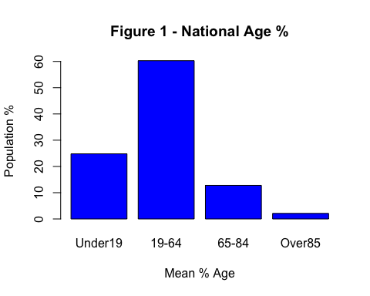

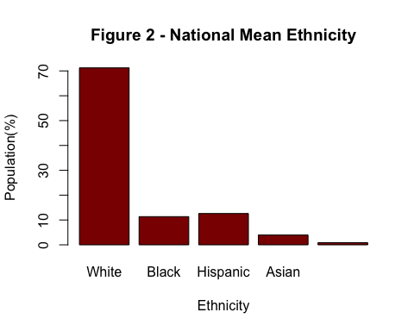

**Population Health Statistics**

The data set contained rich information pertaining to life expectancy and major risk factors contributing to the reduction in life expectancy. The goal, is to use this data to better understand how to reduce the risk of premature death. In looking at the major contributors to premature death; High Blood pressure, No Exercise, Obesity, and Smoking led the way (Figure 3).

It was analyzed to see what percent of the population of the death was caused due to Suicide and homicide(Figure 5). This actually shows the mental state of the population to a certain extent. ~25% of death is caused due to suicide and homicide which is a high number of the population. Below states seem to have a higher rate in 2015 * Texas * New England * Montana * Colorado

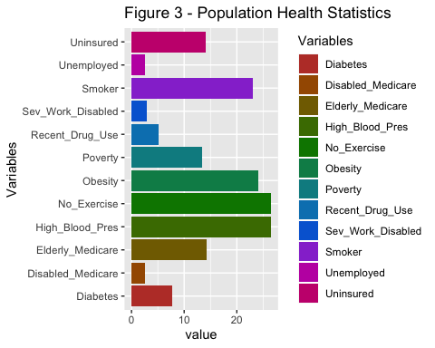

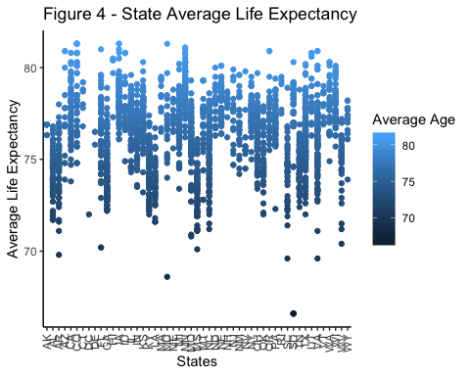

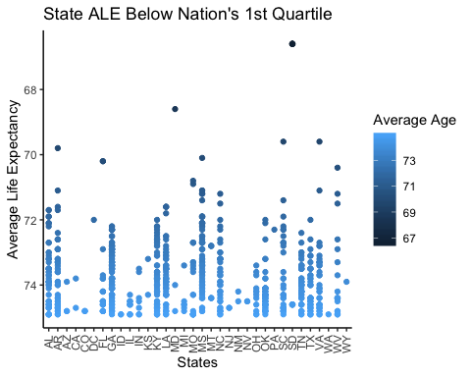

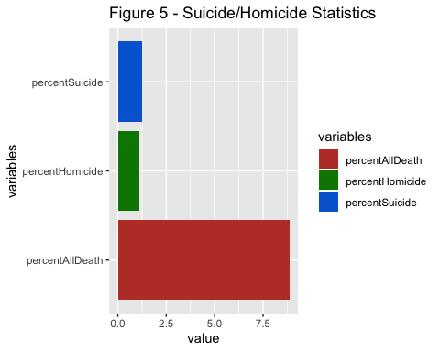

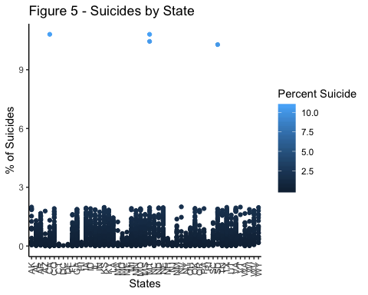

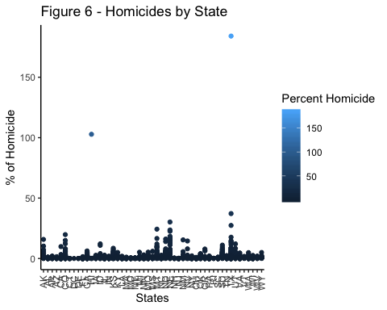

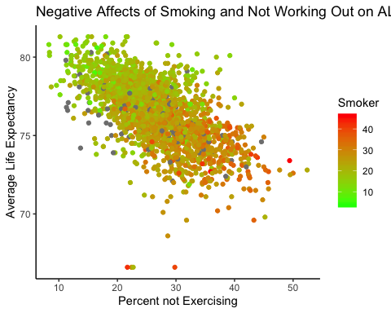

**Maps for Demographics and At risk data**

**AT Risk Clusters MAP**

**http://rpubs.com/randallscott25/CHSIclustersSouthEast**

**http://rpubs.com/randallscott25/CHSIclustersGreatLakes**

**http://rpubs.com/randallscott25/CHSIclustersCentral**

**http://rpubs.com/randallscott25/CHSIclustersWestCoast**

**http://rpubs.com/randallscott25/CHSIclustersNortheast**

**AT Risk Demographic, Categories from EDA with similiartiy clustering**

**http://rpubs.com/randallscott25/chsiDemoPOV**

**http://rpubs.com/randallscott25/chsiVULNunemploy**

**http://rpubs.com/randallscott25/chsiDemoABV19**

**http://rpubs.com/randallscott25/526493**

**Data Models**

## Linear regression

The first step that was taken in the process of transition from “EDA,” by the researcher(s) was to identify: the basic health variables within the data that had to due with negative correlations to life expectancy, to identify and therein see if there was any basic linearity between them. The researcher(s) chose the following correlation matrix visualization to demonstrate the chosen correlation groups; from the CORRPLOT package:

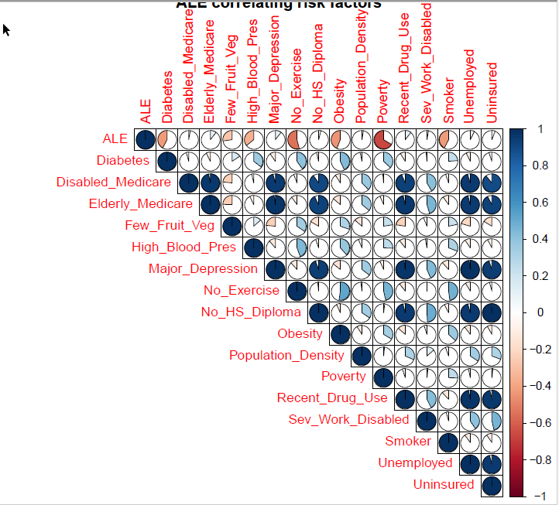

A linear model was built using variables like Age, Demographics, Drug Usage, Use of Toxic Chem, No Exercise, Fruit intake, Blood Pressure, Diabetes and an R-squared value of 71.2% was obtained that explained the variability on Average life expectancy in a county.

* Etnicity does not impact ALE much but it is seen that impact of longer ALE is in the order of Native American, White, Hispanic, Black and Asian It is seen that as the number of people having HIV, Cancer, Diabetes, Heart Disease increases ALE decreases.The order of negative impact on ALE is Heart disease, Smoking, Diabetes, BP, Obesity, HIV

* It is seen that as the number of people having HIV, Cancer, Diabetes, Heart Disease increases ALE decreases. The order of negative impact on ALE is Heart disease, Smoking, Diabetes, BP, Obesity, HIV

* A strong relationship is seen between Unemployed, Drug Usage and Uninsured Being Uninsured has a strong relationship with unemployment, drug usage, receiving elderly Medicare, and disabled Medicare

* Diabetes is having a moderate to strong relationship with obesity, No-exercise, Blood Pressure

* Major Depression and Drug Use are very strongly related. It is noticed that less Fruit intake is moderately related to no-exercise and obesity

**Linear Regression Plots**

1. Residual vs. Fitter Plot - We see there is no specific pattern in the residuals predicted by our model so we can eliminate the possibility of heteroskedasticity and also possible outliers.

2. QQ Plot - Though most of the points seem to fall on the line which indicates that our residuals come from a normal distribution, there are some points that stray from the line in the lower and upper quantiles of the plot. It is possible that these points do not come from a normal distribution, but most of our points seem to come from a normal distribution so there is not a lot to worry about here.

3. Leverage Plot- This plot graphs the standardized residuals against their leverage. It also includes the Cook’s distance boundaries. Any point outside of those boundaries would be an outlier in the x direction. Since we cannot even see the boundaries on our plot, we can conclude that we have no outliers.

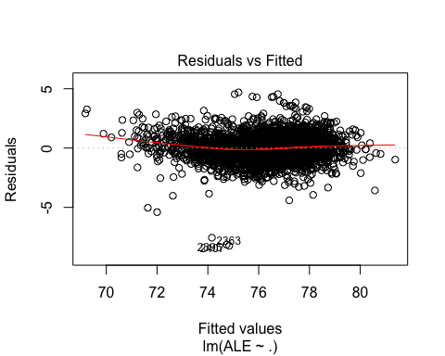

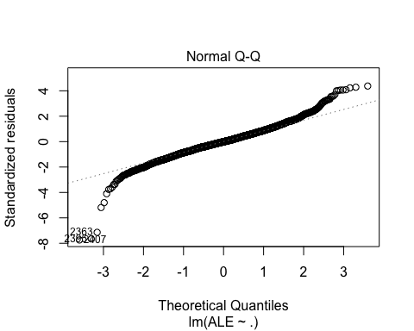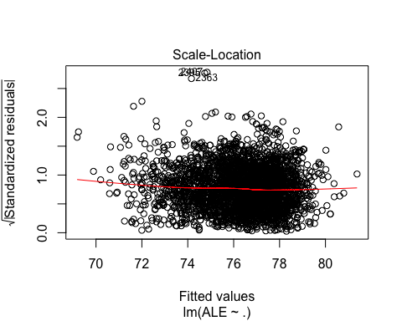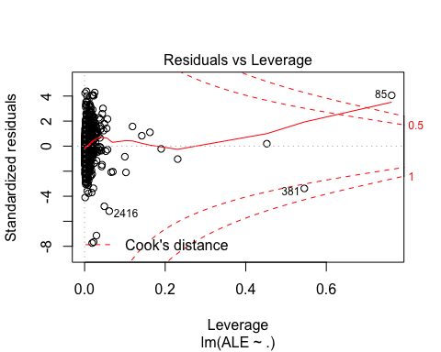

**K-means Cluster Analysis**

Cluster analysis is a popular classification technique frequently used to analyze market research data which divides the data into groups. Data appears in rows, purchase intent scores for example, and columns, sales concepts for instance. Rows can then be clustered with respect to columns or columns with respect to rows. For example, clustering techniques can be used to identify demographic or psychographic characteristics of consumers with similar purchasing histories, or to isolate differences between groups of products. In an attempt to understand the data story better, our research team chose to understand the data points relationship to one another utilizing unsupervised K-means clustering. To find these clusters, we utilized Lloyd’s Algorithm in the following manner: we start out with k random centroids. A centroid is simply a datapoint around which we form a cluster. For each centroid, we find the datapoints that are closer to that centroid than to any other centroid. We call that set of datapoints its cluster, as demonstrated below:

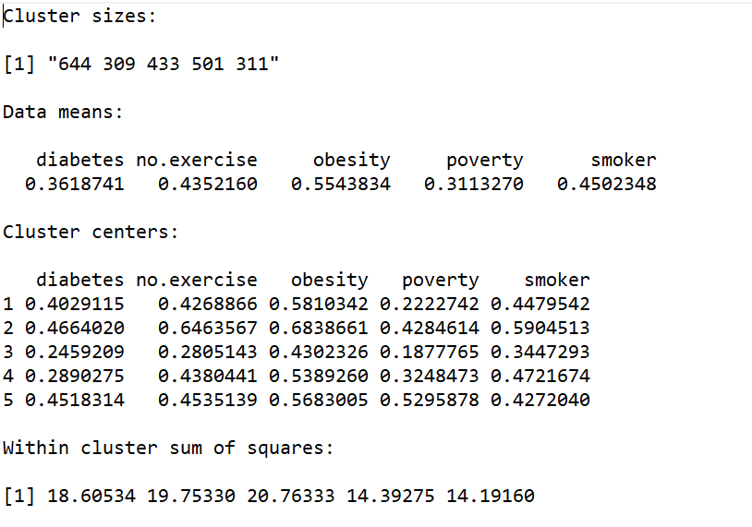Then we take the mean of the cluster and let that be the new centroid. We repeat this process (using the new centroids to form clusters, etc.) until the algorithm stops moving the centroids.

We do this in order to minimize the total sum of distances from every centroid to the points in its cluster *— that is our metric for how well the clusters split up the data*.

General cluster statistics, identified by R analysis:

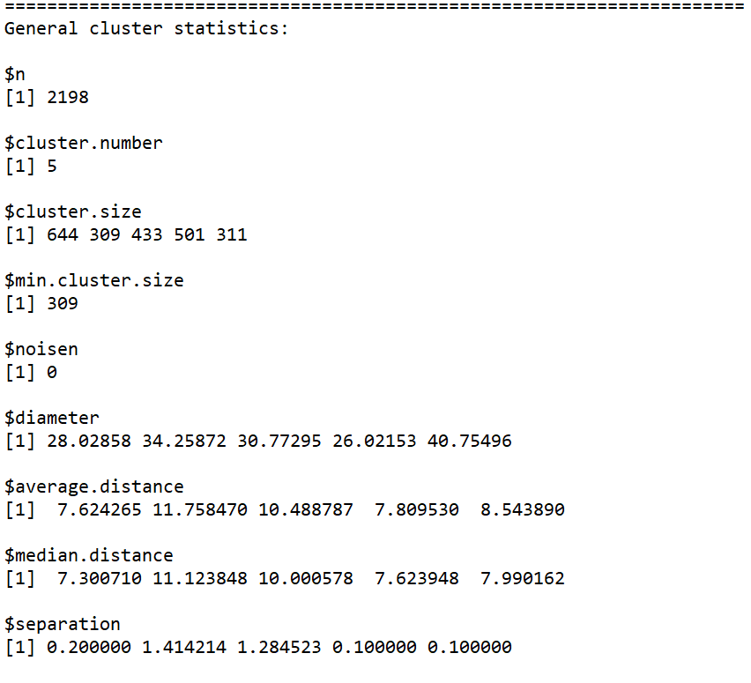

**Distance Measure:**

The choice of distance measures is very important, as it has a strong influence on the clustering results. For most common clustering software, the default distance measure is the Euclidean distance.

Within R it is simple to compute and visualize the distance matrix using the functions get_dist and fviz_dist from the factoextra R package. This starts to illustrate which states have large dissimilarities (red) versus those that appear to be fairly similar (teal).

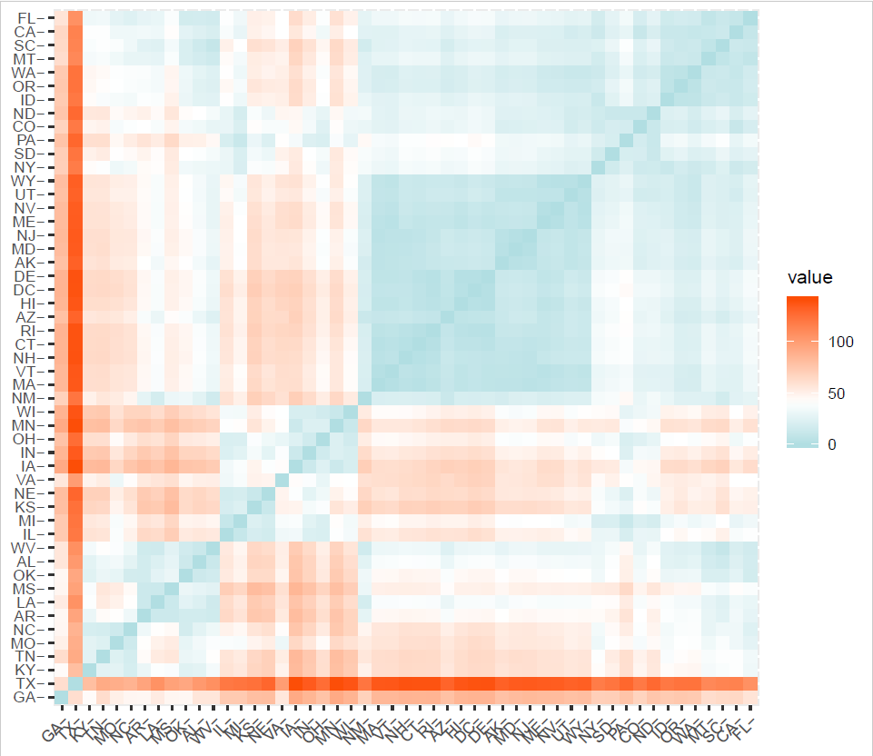

**Finding ‘k’: number of clusters using the elbow method**

The initial cluster analysis was done utilizing a tool within R, the program rattle. The research team then needed to validate the clusters, to ensure that the initial research regarding cluster ability was sound.

To validate the total clusters of **5**, the research team started to conduct validation utilizing the following method:

Chosen variables from the dataset were established as atRisk, and created into a data.matrix. The atRisk data having been established as a data.matrix was then scale the data, to normalize the data by subtracting the mean and dividing by the standard deviation, to take out the effect of different variables, being measured on different scales, and to eliminate the occurrence of NA in our dataset, as this will interfere with the ability of the algorithm to set, and measure, centroids in the k-means clustering.   
Having scaled the data we run an initial, quick function

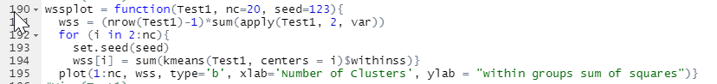

to decide how many clusters to use.

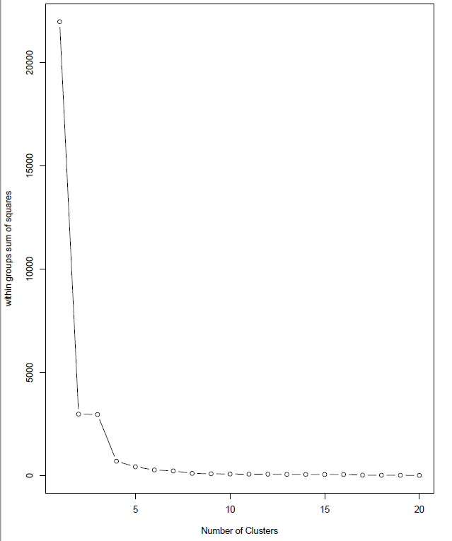

*Initial wss plot function*

***Optimization plots for 3 methods; based upon the NbClust packages***

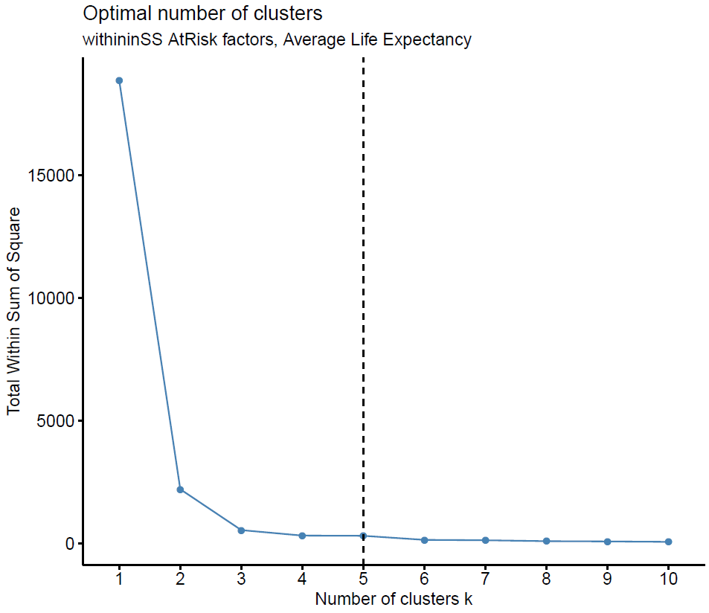**Method 1**: A plot of the total within-groups sums of squares against the number of clusters in a K-means solution can be helpful. A bend in the graph can suggest the appropriate number of clusters, as demonstrated --->

One should choose a few clusters so that adding another cluster doesn’t give much better modeling of the data. More precisely, if one plots the percentage of variance explained by the clusters against the number of clusters, the first clusters will add much information (explain a lot of variance), but at some point the marginal gain will drop, giving an angle in the graph. The number of clusters is chosen at this point, hence the “elbow criterion”

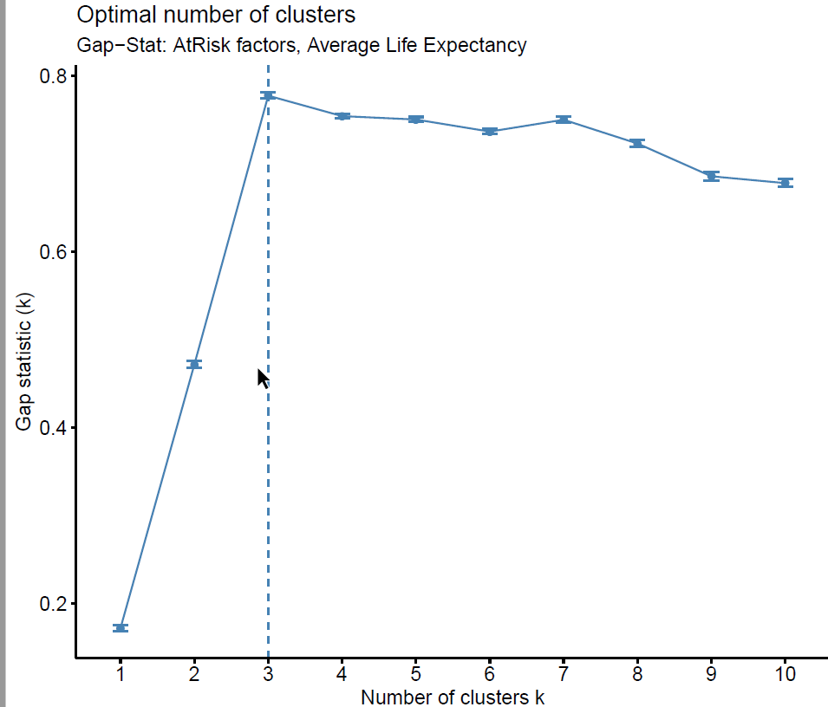**Method 2:** A plot of the Gap-stat tests against the number of clusters in a K-means solution can be helpful. The Gap Statistic compares the total within intra-cluster variation for different values of k with their expected values under null reference distribution of the data. The estimate of the optimal clusters will be value that maximize the gap statistic (i.e., that yields the largest gap statistic). This means that the clustering structure is far away from the random uniform distribution of points. A bend in the graph can suggest the appropriate number of clusters, as 🡨demonstrated.

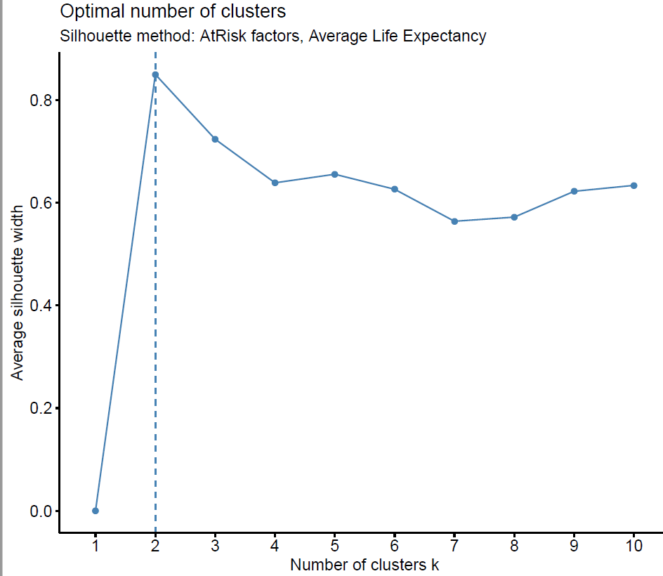**Method 3:** A plot of the silhouette method was chosen as the final optimization plot. Average silhouette method computes the average silhouette of observations for different values of k. The optimal number of clusters k is the one that maximize the average silhouette over a range of possible values for **k**. A bend in the graph can suggest the appropriate number of clusters, as

🡨demonstrated.

**K-means analysis**

Having utilized the above three methods, the research team decide to chose 5 as the total amount of clusters to express in the k-means analysis. Given the previously ran correlation matrix, and initial linear regressions ran; the following visualization shows the initial cluster visualizations ran in R:

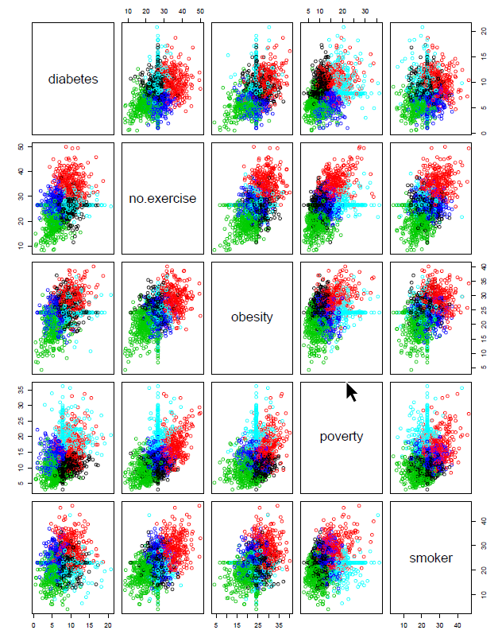

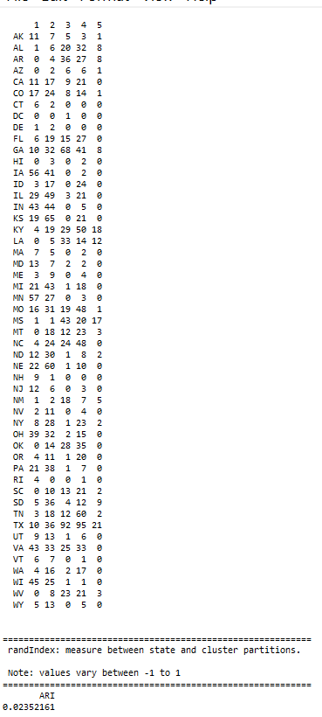After the assignment step, the algorithm computes the new mean value of each cluster. The term cluster “centroid update” is used to design this step. Now that the centers have been recalculated, every observation is checked again to see if it might be closer to a different cluster. All the objects are reassigned again using the updated cluster means. The cluster assignment and centroid update steps are iteratively repeated until the cluster assignments stop changing (i.e until convergence is achieved). That is, the clusters formed in the current iteration are the same as those obtained in the previous iteration.

Computing k-means clustering in R

We can compute k-means in R with the kmeans function. Here will group the data into two clusters (centers = 5). The kmeans function also has an nstart option that attempts multiple initial configurations and reports on the best one. For example, adding nstart = 20 will generate 20 initial configurations

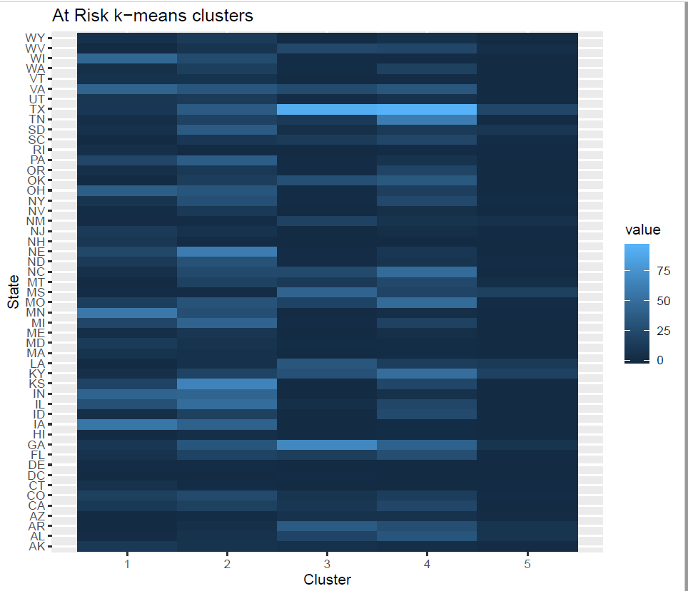

Extracting Results

With most of these approaches suggesting 5 as the number of optimal clusters, we can perform the final analysis and extract the results using 5 clusters. In order to better understand these clusters, the research team utilized the fviz_cluster package, the ggplot2 package, and ggmap r packages for visualization.

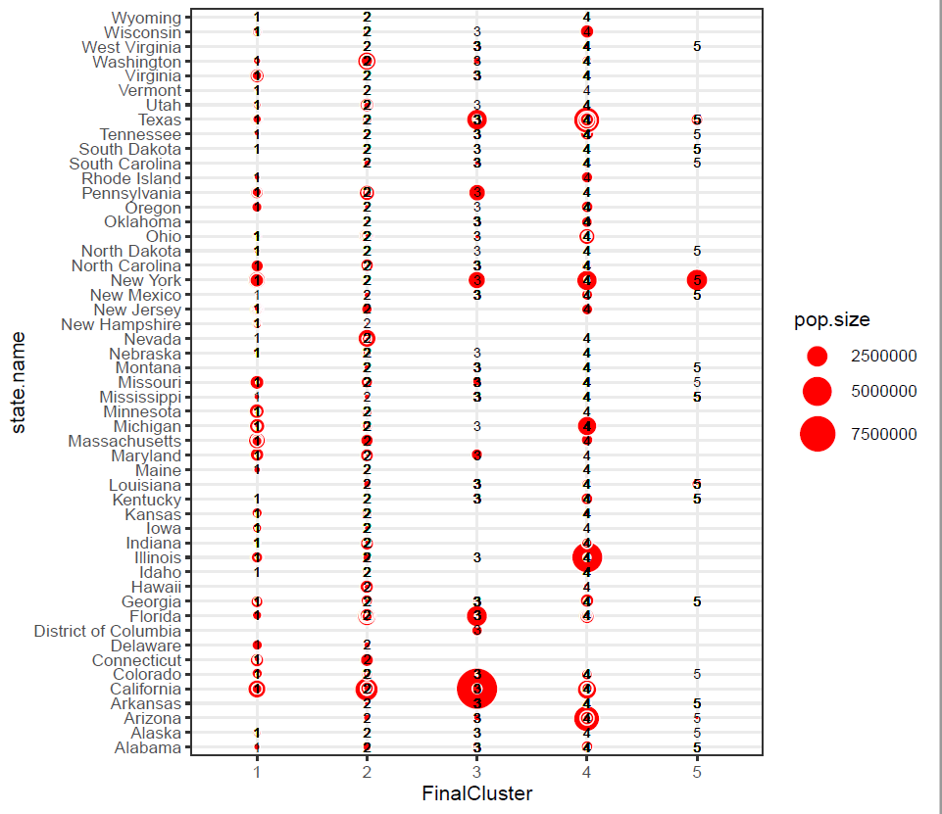

Final cluster chart, At Risk factors, CHSI

Given that the nature of our dataset is based upon a geographic plane, the research team found it expedient to demonstrate the 5 clusters of the data set on the map, as to better understand the distribution of these clusters via there geographic location, and to determine whether or not there was any explanation to that distribution in this unsupervised method. Utilizing the ggmap package; the following maps demonstrate the 5 clusters distribution; Whole, East Coast, West Coast, Great Lakes, South East Region, New York City Metro area.

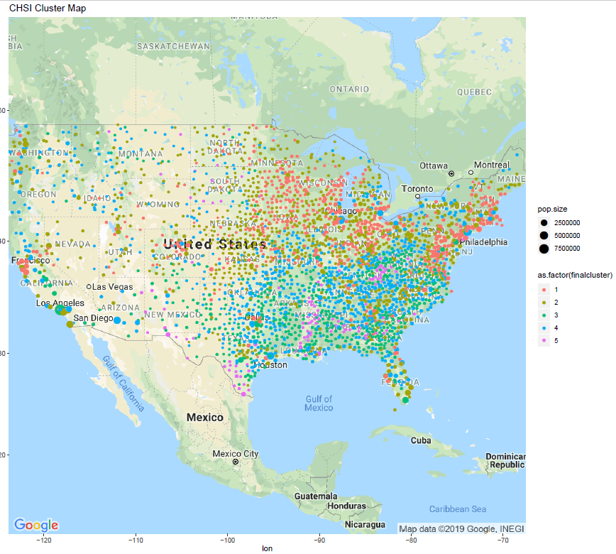

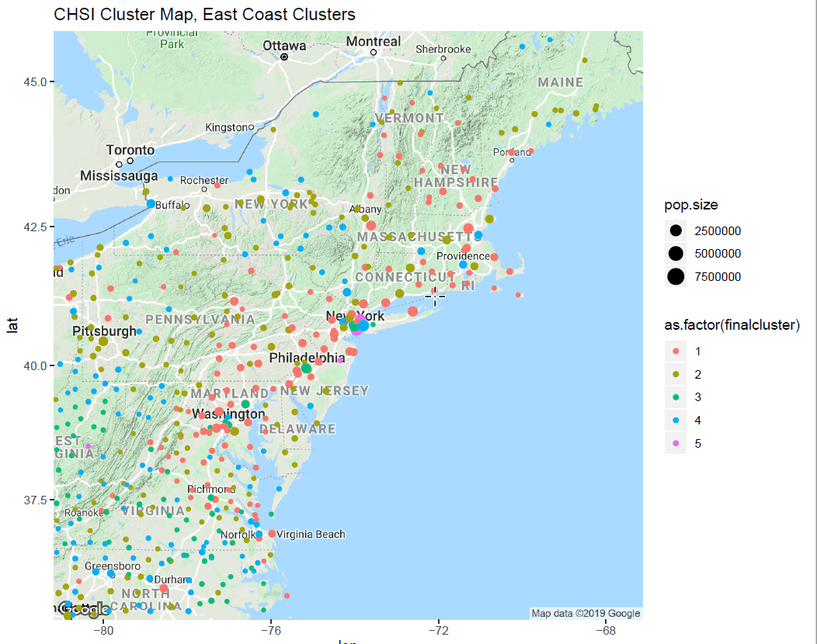

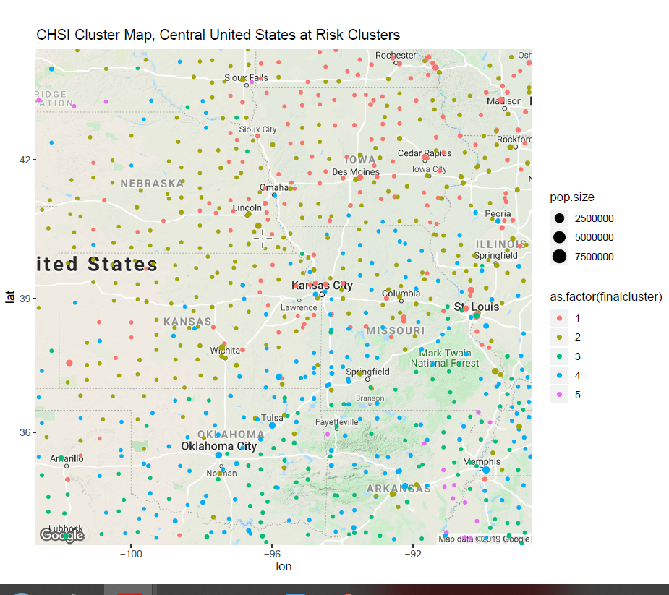

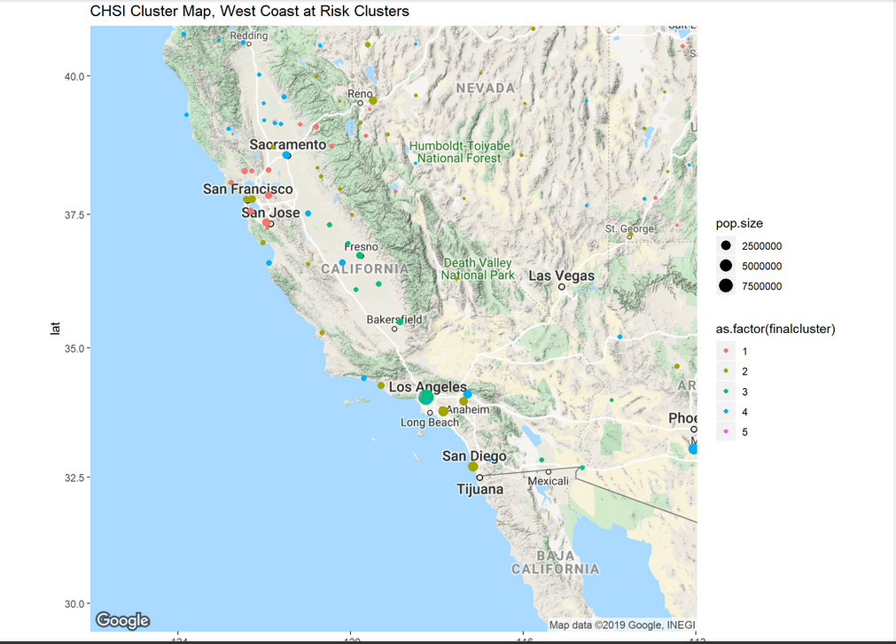

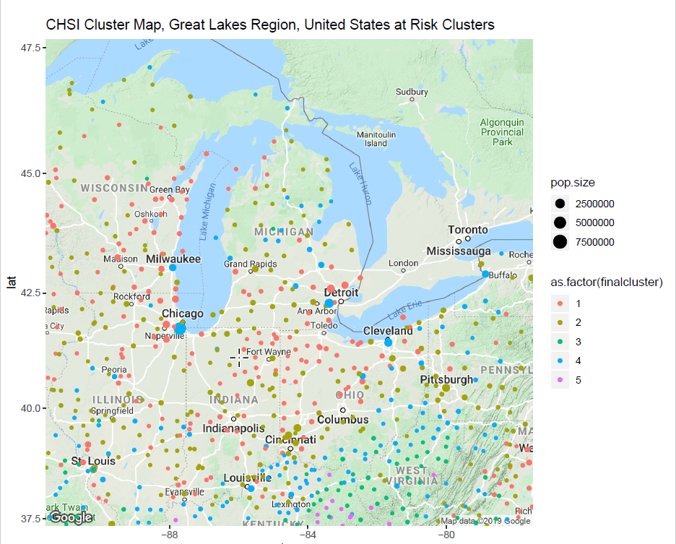

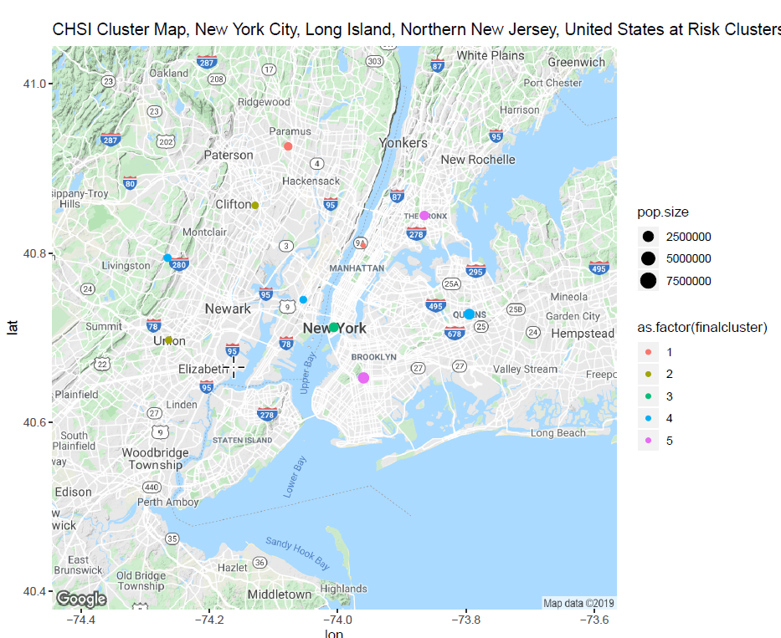

What are the clusters telling the research team?

There is a patten that has been identified within the data. The at risk factors that contribute negatively to average life expectancies have cohesion of the data points within the clusters and separation between clusters.

The nature of the clustering is not being determined by urban versus rural areas. In examination of the cluster’s distribution around the nation, high urban areas like the west coast and east coast, the clusters contained within areas such as San Jose, San Francisco, and, Los Angeles – all belong to different cluster groups. Indeed, in examination of the New York City Metro area, this is expressed profoundly in the cluster differences found in Manhattan, compared to all the other boroughs and metropolitan surrounding areas, and indeed could be a benchmark as to the interpretation of the results. Look at the below example:

Manhattan is listed in Cluster 3, whereas The Bronx and Brooklyn are listed in Cluster 5. Queens is listed within Cluster 4. Northern New Jersey communities of Paramus and Clifton are all listed in different clusters than New York City, with the highland New Jersey Region near Livingston, having a correlation in clustering with Queens.

Finally, given the nature of the clustering, and, that one of the at risk community factors to the diminishment of Average Life Expectancy is Poverty, the research team found some interesting similarities in the nature of the distribution of poverty within the nation, versus, the nature of the clustering algorithm as determined by the unsupervised k-means analysis upon the data, as shown by a couple of at risk and demographic maps:

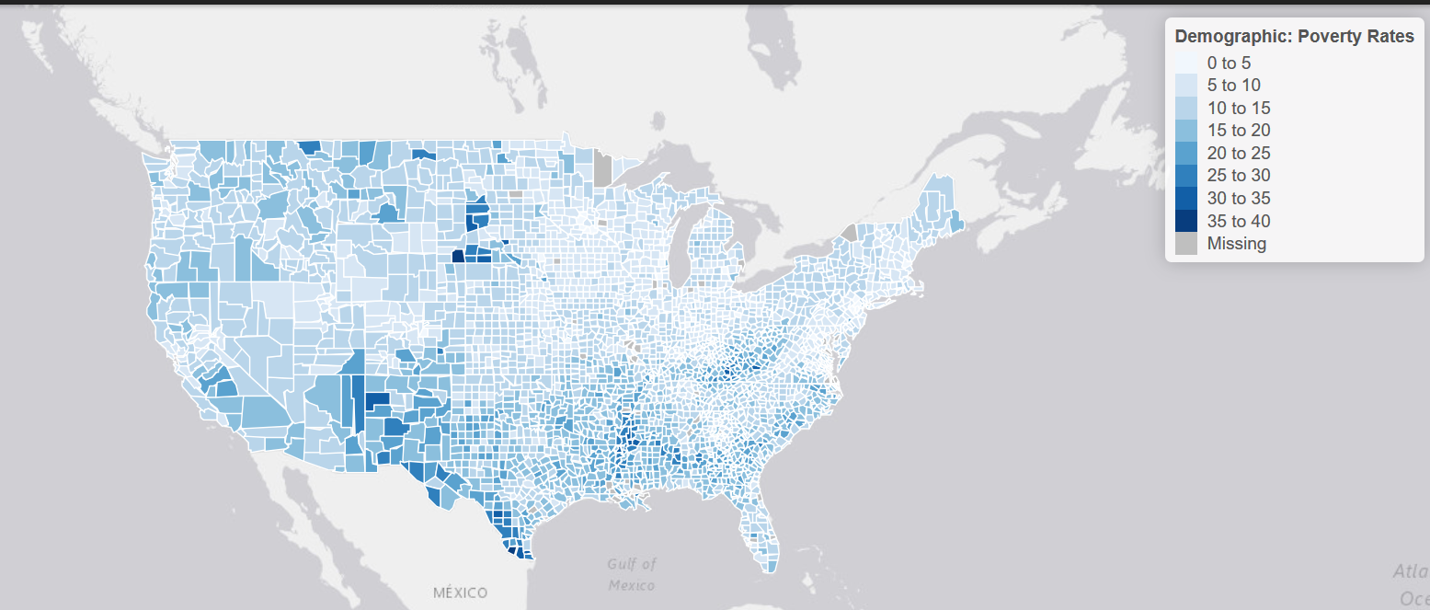

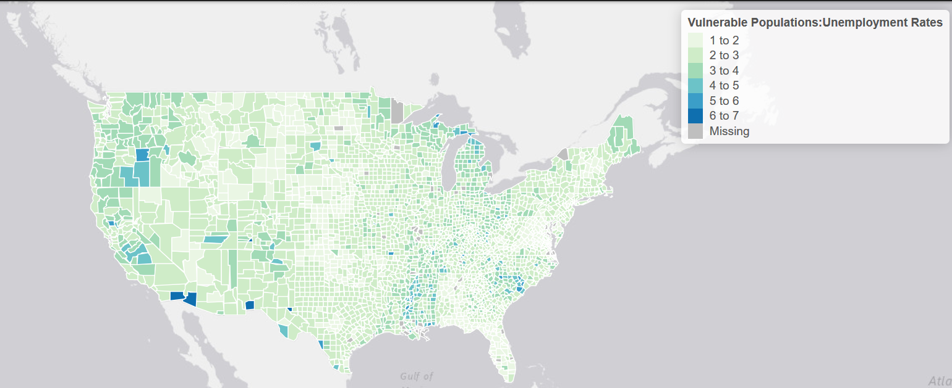

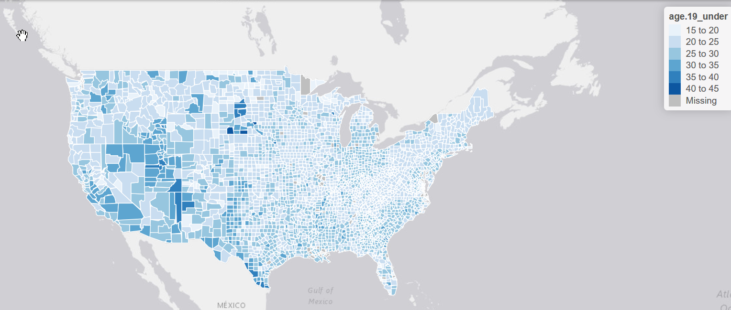

**svm model**

Several svm models were tried by varying kernel and cost attributes. Linear and Polynomial kernal gave an error of 0.03% for a cost of 1 and 50. So we decided to go with a cost of 1 with the linear model.

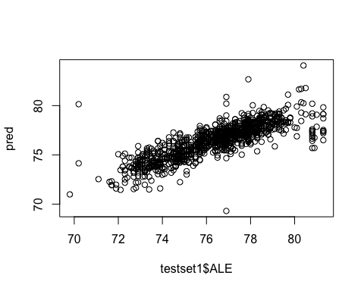

plot(svm1,trainset1)  
  
# svm-linear, cost = 20  
testset1 <- ndf[1:1000,]  
trainset1 <- ndf[1001:3142,]  
svm1 <- svm(ALE ~., data = trainset1, kernel = "linear", type = "eps", cost = 20)  
pred=predict(svm1, testset1, type=c("eps"))  
library(caret)  
conf.linear <- data.frame(pred,testset1$ALE)  
sqrt((mean(conf.linear$pred-conf.linear$testset1.ALE)^2))

## [1] 0.03056059

# svm-polynomial, cost = 50-0.03  
testset1 <- ndf[1:1000,]  
trainset1 <- ndf[1001:3142,]  
svm1 <- svm(ALE ~., data = trainset1, kernel = "polynomial", type = "eps", cost = 50)  
pred=predict(svm1, testset1[,-38], type=c("eps"))  
library(caret)  
conf.polynomial <- data.frame(pred,testset1$ALE)  
sqrt((mean(conf.linear$pred-conf.linear$testset1.ALE)^2))

## [1] 0.03056059

# svm-polynomial, cost = 50- 0.039  
testset1 <- ndf[1:1000,]  
trainset1 <- ndf[1001:3142,]  
svm1 <- svm(ALE ~., data = trainset1, kernel = "radial", type = "eps", cost = 50)  
pred=predict(svm1, testset1[,-38], type=c("eps"))  
library(caret)  
conf.radial <- data.frame(pred,testset1$ALE)  
sqrt((mean(pred-testset1$ALE)^2))

## [1] 0.03981619

# Decision Tree

A decision tree model was built using different rpart paremeters like maxdepth and minsplit. A model with maxdepth of 7,minsplit of 200 yeilds the best result with least error of 8.2% and an accuracy of 91.8%

#install.packages('rpart')  
#install.packages('rpart.plot')  
library(rpart)  
library(rpart.plot)  
set.seed(50)  
dt <- rpart(ALE~.,trainset1,method = "anova", control = rpart.control(cp = 0, maxdepth = 7,minsplit = 200))  
rpart.plot(dt)

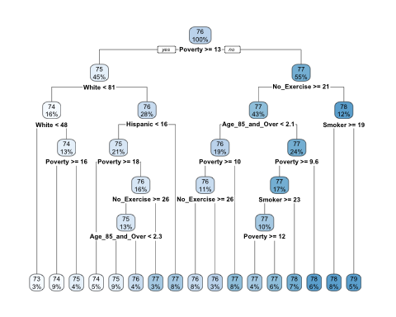

pred_dt <- predict(dt, testset1[,-38])  
library(caret)  
conf.dt <- data.frame(pred,testset1$ALE)  
sqrt((mean(pred_dt-testset1$ALE)^2))

## [1] 0.08064625

# Random Forest

A random forest model was built using different number of trees 5,20,17. A model with 11 trees yeilded the best result with least error of 8.3% and an accuracy of 92%

#install.packages("randomForest")  
#install.packages("caret")  
library(randomForest)

library(caret)  
set.seed(50)  
rfm_chsi <- randomForest(ALE~., data=trainset1, ntree=11, na.action=na.exclude)  
print(rfm_chsi)

##   
## Call:  
## randomForest(formula = ALE ~ ., data = trainset1, ntree = 11, na.action = na.exclude)   
## Type of random forest: regression  
## Number of trees: 11  
## No. of variables tried at each split: 12  
##   
## Mean of squared residuals: 1.393254  
## % Var explained: 63.78

predRF <- predict(rfm_chsi, testset1[,-38])  
conf.RF <- data.frame(pred,testset1$ALE)  
sqrt((mean(predRF-testset1$ALE)^2))

## [1] 0.08227802

plot(pred,testset1$ALE, col='red', main="Random Forest")

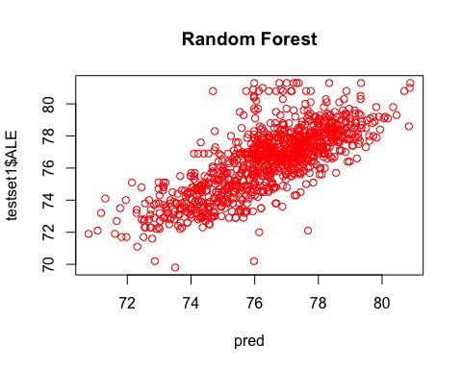

# Naïve-Bayes

Our Naïve-Bayes analysis proved more difficult to implement due to several factors (please refer to R file). While training, this author’s R resulted in a “fatal error” and most all the quarter’s variables were lost due to an unsaved workspace. This was a good learning moment, however, and showed us the necessary computing power for such a large analysis.

**Result**

Our objective was to find factors that impact ALE so that the findings will aid health agencies or government to assist population in those areas. To do this we derived many models to understand the important factors.

Below is a summary of the models built to understand ALE and factors affecting it

|  |  |  |  |  |
| --- | --- | --- | --- | --- |
| **# models** | **model** | **accuracy** | **error** | **cost** |
| model 1 | Linear regression | 71.20% |  | **-** |
| model 2 | svm-linear kernel | 96.50% | 4% | 1 |
| model 3 | svm-linear kernel | 96.94% | 3% | 20 |
| model 4 | svm-ploynomial | 96.95% | 3% | 50 |
| model 5 | Random Forest | 92.00% | 8% | - |
| model 6 | Decision Tree | 91.80% | 8% | - |

* The results from **linear regression model** gave an understanding that 71.2% of the variability in ALE could be explained by the below factors which were used to build a model. The maximum impact being in the order of Ethnicity, Poverty, HIV, Obesity and Blood Pressure.

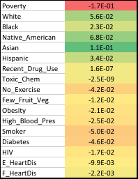

* **Correlation** analysis revealed that having No_highschool diploma is highly related to depression, being uninsured, unemployed, use of drugs that impact ALE strongly.
* Kmeans Result helped us understand segments in our population data
* Random Forest and Decision Tree models provided almost the same accuracy of ~92% with major decision making attributes being Poverty, Ethnicity, Exercising and Smoking.
* SVM with different kernels tried almost consistently gace a good result of ~97% accuracy with the factors being Ethnicity, Poverty, Exercising and Smoking.

# Conclusions

1. The data set we chose really does fit it’s intended purpose, which was to assist local health agencies with assessing the needs of their communities. In addition, armed with this data they would be able to create programs and services that would directly impact the overall health of their communities.
2. Irrespective of how you cut the data, we saw that a lack of education (defined as no HS diploma) had the single largest impact on overall health. Though it wasn’t directly significant in the linear model, it had a high correlation to things like unemployment, drug use, and depression. These in turn contribute to a lower Average Life Expectancy (ALE). Programs that target education and/or gainful employment, especially in rural counties, would seem to have the largest impact.
3. In addition, communities with adverse behavioral or lifestyle choices (most notably those who don’t exercise, those who eat few fruits/vegetables, and those who smoke) are statistically more at risk for premature death. These correlations (negative correlative value to life expectancy) are within the individual’s control and would benefit from additional support within the community.
4. A general observation of the project is that while we chose a data set that allowed for each individual to learn something or probe in a different direction (e.g. some thinking about cancer, some looking at mental health and others suicide rates) it created a challenge in focusing in on a cohesive data story. The team was often caught between applying things we had learned in class (tools - ensure we “check all the right boxes”) and really understanding what the data was telling us. It was a great exercise to highlight the challenges in translating business needs (what do you want to know, how do you want to use the data) and the data side (coding) to ensure they are aligned.